**Question One**

Consider the code fragment below and complete the paint method to achieve the image shown below it

public class NewClass extends JFrame {

public NewClass(){

setTitle("My work");

setVisible(true);

setDefaultCloseOperation(EXIT_ON_CLOSE);

setSize(400, 400);

}

public void paint(Graphics g){

super.paint(g);

}

public static void main(String[] ag){

NewClass newc= new NewClass();

}

}

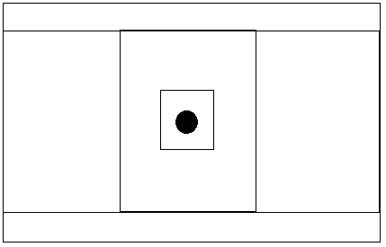

**Question 2**

Consider the code fragment below and complete the paint method to achieve the image shown below it

public class NewClass extends JFrame {

public NewClass(){

setTitle("My work");

setVisible(true);

setDefaultCloseOperation(EXIT_ON_CLOSE);

setSize(400, 400);

}

public void paint(Graphics g){

super.paint(g);

}

public static void main(String[] ag){

NewClass newc= new NewClass();

}

}

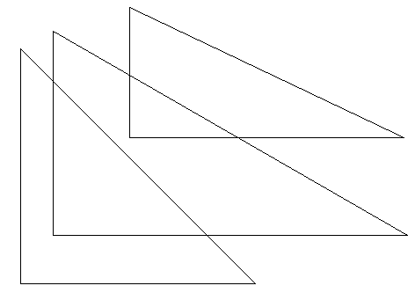

**Question 3**

Omar uses Internet banking. This pseudocode checks her PIN

C 🡨 0

INPUT PIN

X🡨PIN

REPEAT

X 🡨 X/10

C 🡨C+1

UNTIL X< 1

IF C<> 5

THEN

PRINT “ERROR IN PIN”

ELSE

PRINT “PIN OK”

ENDIF

What vale of c and what message would be output if the following PINS were entered?

* 1. 51020
  2. 5120

**Question 4**

Consider the pseudocode below

INPUT A

INPUT B

INPUT C

INPUT D

INPUT E

INPUT F

INPUT G

INPUT H

INPUT I

INPUT J

INPUT K

T = A+ B+C+D+E+F+G+H+I+J+K

OUTPUT T/11

Write a Java code to implement the code above using the concept of ARRAYS